IFMA Program Review Committee - Call for Volunteer Applications | 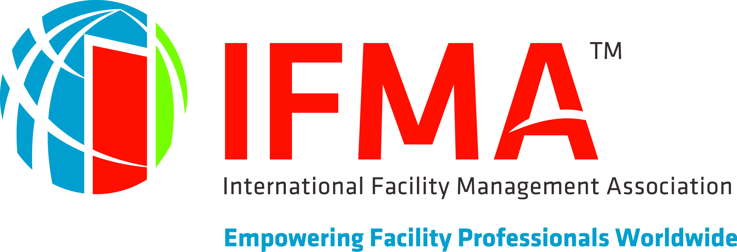

Help shape the future of facility management education and training by volunteering to serve on the program review committee for IFMA’s conferences.

By volunteering you:
- Help shape the conference programs
- Gain continuing education
- Become recognized as an FM thought leader
- Learn from industry experts
- Network with industry peers
- Give back to your profession
- Become an IFMA insider

Expectations and Requirements

To apply, you should:
- Be a member in good standing with IFMA
- Have experience and/or expertise in one or more of the FM core competencies below
- Be willing to review, score and discuss conference program submissions
- Work with the program committee via email and conference call(s)

Contact Information
Name
Credentials (if applicable)
Title
Company
Address
Phone number
E-Mail Address
Years in the industry
Area(s) of expertise
IFMA Member number

Interests

Please indicate what core competencies you would most be interested in reviewing. You may select multiples competencies.
Operations and Maintenance
Real Estate & Property Management
Human Factors
Environmental Stewardship & Sustainability
Project Management
Leadership & Strategy
Finance & Business
Quality
Communication
Technology
Emergency Preparedness & Business Continuity

FM Industry Experience

Please list any FM industry conventions that you have attended:

Please list any FM industry conventions that you have presented at:

Please list any other information/items you think IFMA should consider reviewing your application:

Agreement and Signature

By submitting this application, I affirm that the facts set forth in it are true and complete. I understand and accept the expectations and requirements as a volunteer.
Name (printed)
Signature
Date

Thank you in advance for your service!

Once completed, please sign and send to:

Monica Grinage Cooper, CMP
Event Program Manager
monica.grinagecooper@ifma.org | p: +1-281-974-5649 | f: +1-281-974-5672
