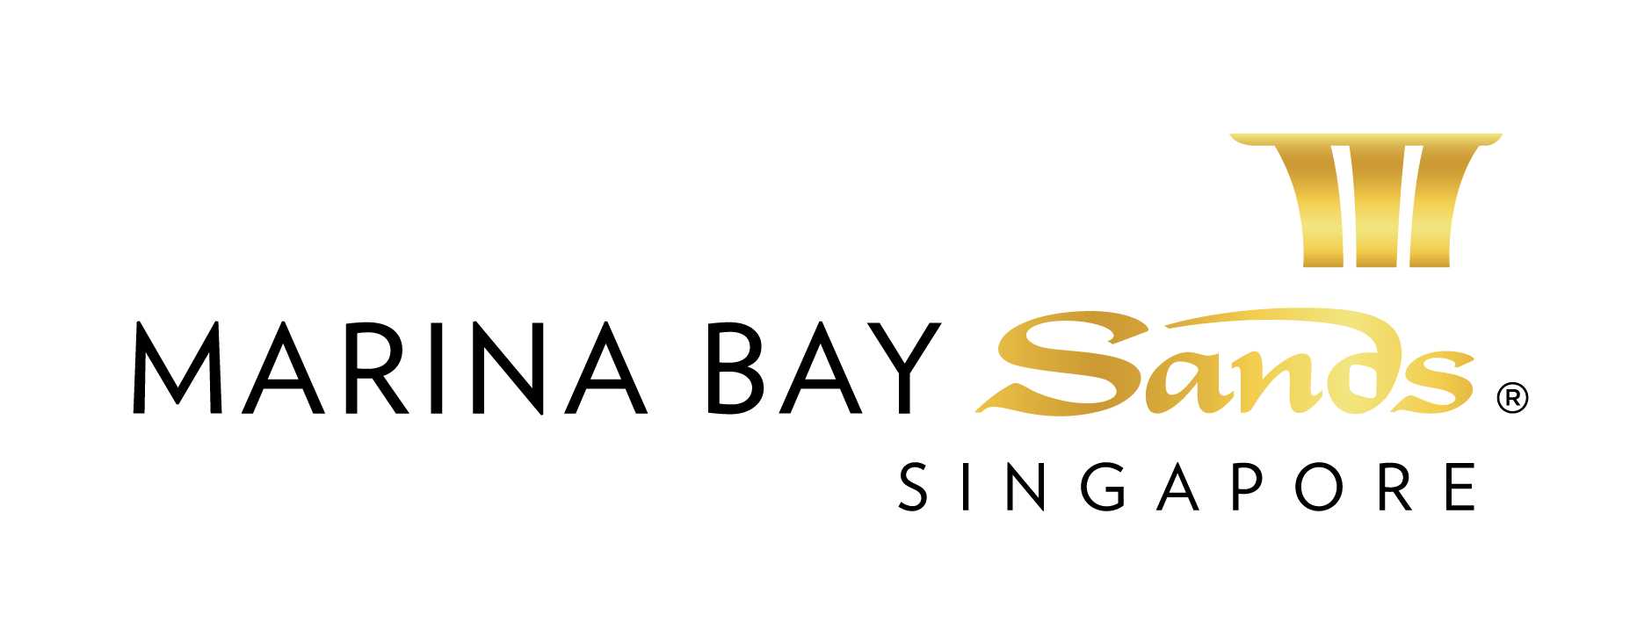 HOTEL RESERVATION FORM
World Workplace Asia Conference 2015 | August 02, 2015 to August 05, 2015

Please return the completed form to Marina Bay Sands, Group Reservations Department (email: groups@marinabaysands.com) by Thursday, July 02, 2015 (Cut-Off Date) . All bookings are subject to room availability and the best rate available after Thursday, July 02, 2015 (Cut-Off Date).
Salutation: | Dr |  | Mr | Mrs | Ms |  | Others (please specify): |  | PARTICULARS
Family Name: |  |  |  |  |  | Given Name:
Designation: |  |  |  |  |  | Company:
Address:
City / State: |  |  |  |  |  | Country:
Telephone: |  | ( ) |  |  |  | Fax: |  | ( )
Email:

Passport No.: |  | Passport Expiry: |  | TRAVEL DETAILS
Date of Birth: |  | Nationality:
Additional Guest Name:
Passport No.: |  | Passport Expiry:
Date of Birth: |  | Nationality:
Arrival Date: |  | Departure Date:
Arrival Flight: |  | Departure Flight:

Room Type | Rate* | Special Requests** | Number of Nights | ROOM CATEGORY
King  Double-Double | Deluxe  SGD365.00++  (Includes Internet Access) |  | nights
Airport Limousine Pick up at S$225.00 NETT per way (Please tick if required):
Please furnish us your credit card and flight details in order to guarantee your limousine arrangement:
Arrival (airport-hotel) Departure (hotel-airport) 2 way transfers required (airport-hotel-airport)

Please let us know of any special requests you may have, so that we can make every effort to ensure your stay is comfortable.
Other special requests:
* Rates are subject to 10% service charge and prevailing Goods and Services Tax (GST).
** Subject to availability.
Please note:
- Check-in time begins at 3:00pm and check-out time is by 11:00am
- The request for bed type (1 single King bed or 2 Twin beds) is subject to availability.
- All reservations must be guaranteed with a credit card. Please provide flight details if applicable
- Any cancellation/ amendment of reservation must be made by Thursday, July 02, 2015, failing which room charge of the full length of stay requested (plus 10% service charge & 7% goods and services tax) would be incurred to the credit card details of the individual attendee(s) provided for guarantee.
- Please be advised that in the event of no show, full cancellation charge will incur (plus 10% service charge & 7% goods and services tax).
- A confirmation number will be sent to you once the booking has been made

To guarantee your reservation, kindly provide your credit card details in the space below:
Name on Credit Card:

Card Number: |  |  |  |  | - |  |  |  |  | - |  |  |  |  | -

Card Type: | Visa MasterCard American Express Diners JCB

Expiry Date: |  |  | / |  |  |  |  | (mm/yyyy)

By providing my credit card details, I hereby authorise Marina Bay Sands Pte Ltd to charge my credit card to guarantee my reservation.
Credit Card Signature: |  | Date:

