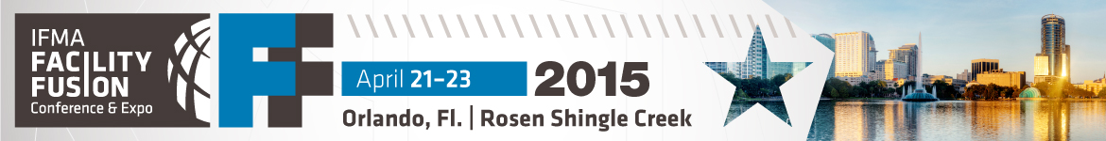

IFMA Facility Fusion ROI Worksheet

After you submit the proposal letter to your employer/supervisor, be prepared to discuss specifics in a face-to-face meeting. Make the connection between what your employer expects from you and how the conference can heighten your performance in those areas.

Personal Goals
How will your attendance help you meet demands and make a perceptible difference in your organization?

Tip: Identify sessions and activities that are directly applicable to your job, current projects and facility challenges, and outline what you expect to take away from each; for example:

- Need to focus on soft management skills? Choose sessions under the leadership training track to better lead your FM team.
- Need to do more with less? Select sessions focused on managing budget cuts and financial tools for FMs.
- Need strategies for sustainability or flexible work programs? Choose sessions that address workplace efficiency, managing mobile workers and leading change.
- Need products for a current or upcoming facility project? Save hours of independent research by asking questions of exhibiting companies at the expo.

Business Objectives
What will your organization gain as a result of your attendance?

Tip: Communicate the value of the investment or time away from the office in terms that are important to business executives, such as:

- A competitive edge.
  - I’ll acquire the latest best practices for improving operational efficiency, as well as field-tested strategies for increasing employee productivity through a better work environment.
- A measurable boost in operational efficiencies.
  - I’ll acquire action plans and proven techniques for heightening facility performance that can be applied immediately for direct results.
- Assurance of excellence.
  - Supporting my continuing education ensures that our facility is being managed by an informed and prepared professional.
- A valuable list of contacts.
  - I’ll connect with fellow practitioners, topic experts and reputable solution providers who I can call on for ideas, advice and recommendations.
- Money well spent.
  - Full event registration is an all-access pass, allowing me to gain a wealth of relevant information in one place, for one price.

