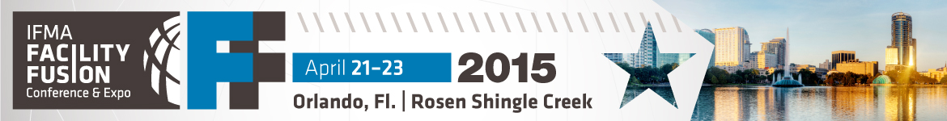

<Date>

Dear <Employer/Supervisor>,

I am writing to request time off <and/or> financial support to attend IFMA’s Facility Fusion 2015 Conference & Expo, held April 21-23, in Orlando, Florida.

Hosted by the foremost international association for facility professionals, Facility Fusion features two days of educational sessions focused on facility management best practices, proven methods for efficient workplace operations and maintenance, and leadership training.

Continuing education, especially from a resource as reputable as IFMA, benefits us both. What I gain will help me meet my professional goals, and better support and contribute to our overall business objectives. Returning with the most up-to-date information on industry trends and standards will help me ensure that we’re current, compliant and competitive.

Led by experts in project and risk management, strategic planning, environmental stewardship, innovative business/workplace practices, and facility/workforce performance, sessions are categorized by topic track and experience level, allowing me to tailor a learning agenda applicable to my job responsibilities and our existing facility issues.

Facility Fusion is geared toward one-on-one networking. Consulting with colleagues and solution providers on site allows me to compare what others are doing in their facilities, and return with recommendations for introducing improved practices and products in our workplace. I can subsequently call on those in my professional network for ideas and advice.

<Members: insert this paragraph>
If I register before March 27, 2015, I can save US$200 off the full event price. As an IFMA member, I’m already saving US$196 off the nonmember price, a significant benefit of my membership.

<Nonmembers: insert this paragraph>
If I register before March 27, 2015, I can save US$200 off the full event price. The registration fee includes one year of IFMA membership — a significant value and an incredible opportunity to benefit from resources through the principal organization for my profession.

I would greatly appreciate the opportunity to discuss, at your convenience, the advantages and associated costs of my attendance. I can provide you with a sample learning agenda, outlining the sessions and speakers that best fit our FM needs. Please reference the attached Benefits Summary for more information.

Sincerely,

<Name>
<Title>
<Department>

