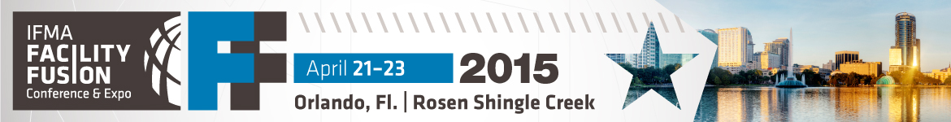IFMA Facility Fusion Benefits Summary

Educational sessions that are directly related to our current facility challenges, overall business objectives and my professional goals:

Session title: | Benefit(s) of attending:

Other conference activities I’m interested in — some are included in full event registration; some require an additional fee:

Activity: | Benefit(s) of attending:
Workplace Evolutionaries Pre-Conference  Monday, April 20, 8 a.m. - 5 p.m.  Additional fee: | Stay on top of the changing nature of work, its effect on the physical workplace and its importance in attracting & retaining top talent.
Facility Tours  Thursday, April 23, 2 p.m. - 5 p.m.  Addition fee: US$20/tour | First-hand look at energy-efficient features, building upgrades & strategic space planning, with insights from the FM team on daily operations.
Welcome Reception & Expo Grand Opening  Tuesday, April 21, 4 p.m. - 7:30 p.m.  Included | Network with attendees & vendors in a relaxed setting; gain information on solutions to existing or impending facility issues.

