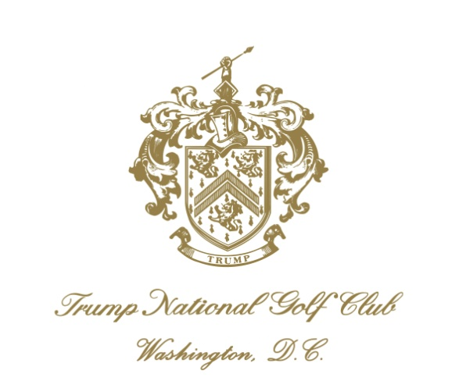
Position opening: Facilities Manager Posted: March 21, 2016
Trump National Golf Club, Washington DC www.trumpnationaldc.com
Position summary: The Facilities Manager is a key member of the Management Team at Trump National Golf Club, Washington DC. We are looking for a hands on candidate who has strong communication skills and a passion for maintaining the facilities in an excellent fashion. The individual must have an eye for detail, a sense of urgency and be driven to providing exceptional service to our management team while ensuring that the facilities are clean, secure and well maintained. The responsibilities of this position centers around day to day operations of the entire clubhouse and surrounding buildings. The successful candidate will be responsible for supervising and providing leadership to our maintenance, housekeeping and security team.
Experience required: Candidate must have significant and related experience in facilities operations in a private club setting, large restaurant or upscale hotel. The ideal candidate will have a solid foundation in the areas of maintenance and repairs, housekeeping and security and will have the desire to keep learning. This role requires a hands on person with excellent team service and communication skills. Must have experience with the Clubs HVAC, plumbing, carpentry and electrical system and/or be able to learn new maintenance requirements. Must demonstrate detail-oriented, people person capabilities, and positive interpersonal skills. Must be positive and willing to go above and beyond at all times. Must be able to communicate effectively and fulfill essential job duties while having a sense of urgency. Must be organized and understand contracts and billings to ensure outside contractors are compliant. Must know how to create and adhere to a budget while providing clean and well maintained facilities. Must be reliable and willing to be flexible in hours worked at club which includes working holidays and weekends.
Experience preferred: A minimum of three years’ facilities management experience in a high end quality club or upscale hotel and/or a college education is preferred; however, candidates with demonstrated equivalent training and experience will be considered. This is also an excellent opportunity for a rising star in the private club industry.
- This position reports directly to the General Manager.
- No phone calls or walk-ins please. You may also apply through our web-site
- The club offers a generous compensation package with the opportunity to participate in our health, dental, vision and 401K programs.
- EOE
Please send your resume and cover letter to Michael MacDonald, CCM at mmacdonald@trumpnational.com

