Email registration forms to Joshua Amos at Joshua.amos@ifma.org or mail to Airports Facilities Council, 800 Gessner Road, Suite 900, Houston, TX 77024. Direct Dial: 281-974-5629
Contact Information
Salutation: ☐Dr. ☐Mr. ☐Ms. ☐Mrs.
Name:
Company or Institutional Affiliation:
Email: Click or tap here to enter text. Phone#:
Address:
City: State/Province: Zip/Postal #:

(All Fees are in US Funds)
Air FC Conference Registration – Deadline is April 24, 2017
☐ $275 Member Conference Registration (May 8-10)
☐ $325 Non-Member Conference Registration (May 8-10)
☐ $50 Student Conference Registration (May 8-10)

Vetting for Airport and Air National Guard Tours
Complete Name
NameClick or tap here to enter text. Middle Click or tap here to enter text.
LastClick or tap here to enter text.
Home Address
StreetClick or tap here to enter text.
CityClick or tap here to enter text. State Click or tap here to enter text. Zip/Postal CodeClick or tap here to enter text.
Date of BirthClick or tap here to enter text.
Driver’s License NumberClick or tap here to enter text.
State of Issuance Click or tap here to enter text. Expiration Click or tap to enter a date.

Conference Options
☐ Preconference Tour Monday, May 8, 2017 from 8AM to 11AM – LEED Airfield Maintenance Building and ARFF facilities for attendees of the conference, there is no cost, but registration is required
Monday Night Dinner Option Please Pick ONE
☐ Tour of Knoxville* with Dinner at Calhoun’s (dinner cost is yours) Monday, May 8th
Number of attendees _____
OR
☐ Tour of Cades Cove in the Smoky Mountain National Park* – A picnic style boxed dinner menu will be provided at check in for their box lunch options COST: $12.00 Please note: no Alcohol on this tour Monday, May 8th
Number of attendees ____
***Transportation is included, so registration is required for proper arrangements to be made***
Shirt Order – If you register before April 24th you will receive an Airport Council Polo as part of the registration.
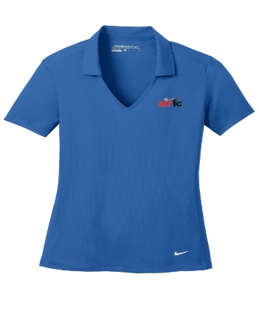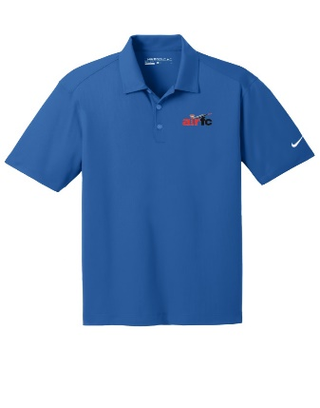
Women’s S-XXL Men’s S-XXXXL

Size _____
Size Chart Men’s: http://www.nike.com/us/en_us/c/size-fit-guide/mens-tops-sizing-chart
Size Chart Women’s: http://www.nike.com/us/en_us/c/size-fit-guide/womens-tops-sizing-chart

Credit Card Billing Information – Use only if Credit Card info is different from information at the top of the form
Salutation: ☐Dr. ☐Mr. ☐Ms. ☐Mrs.
Name:
Company or Institutional Affiliation:
Email: Click or tap here to enter text. Phone#:
Address:
City: State/Province: Zip/Postal #:

Payment Information:
IFMA accepts checks and credit cards. Please make checks payable to Airport Facilities Council. All fees payable in U.S. funds only. No registrations will be processed without payment.
Charge the total amount of $ __________US funds to the following credit card:

☐ Visa ☐ MasterCard ☐ AMEX ☐ Diner’s Club ☐ Discover
Name as it appears on card Click or tap here to enter text.
Card NumberClick or tap here to enter text.

Date of exp:Click or tap to enter a date. CVV Code:Click or tap here to enter text.

Make sure to make your hotel reservations. The host hotel is the Courtyard by Marriot Knoxville Airport Alcoa, make sure to use the link in order to receive the meeting room rate. Please stay in this hotel as the meals are provided by the hotel. The room rate for the stay is $149.00 per night, and valid from May 5-13, 2017, so you can come early and stay late.

We look forward to seeing you there.

